Eduardo Gallego Chillón - 2º DAW

IES Francisco Ayala (Granada)

**EVOLUTION OF THE WEB**



# **Index**

**1.** **Introduction** 2

**2.** **Web 1.0** 2

**2.1.** **Typical web 1.0 design elements** 2

**3.** **Web 2.0** 2

**3.1.** **Web 2.0 features** 3

**3.2.** **Web 2.0 weaknesses** 3

**4.** **Web 3.0** 3

**4.1.** **Functioning of web 3.0** 4

**4.2.** **Application fields of web 3.0** 4

# **Introduction**

The web also known as World Wide Web is one of the most important invents in the history. It was created by Tim Berners-Lee about 1990.

He also created HTML (Hypertext Markup Language) to format web documents, and initially was designed for human reading, not for automatic processing.

Today, the W3C (World Wide Web Consortium) is the international organisation that sets standards for the web. His objective is to make the most of the web, developing standard technologies.

# **Web 1.0**

It was the first version of the web, and it was text only, static and unidirectional (only from client to server). The web was controlled by the webmaster and the content was limited to what he added, so it was not allowed user interaction.

It was oriented to education, military and professional scopes. Little by little it was evolving for to be more visual, introducing images, colours, etc. The first visual browsers were Netscape and Internet Explorer.

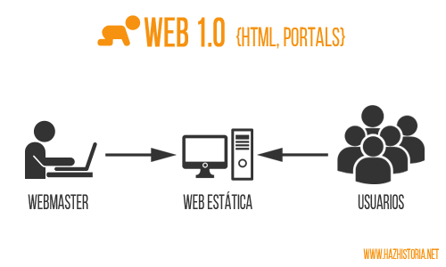

## **Typical web 1.0 design elements**

* Static pages for user’s visit.
* Use of frames.
* Own HTML extensions.
* GIF buttons.
* HTML forms sent via email.

# **Web 2.0**

The web 2.0 was appeared in 2004. Unlike web 1.0, this version is focused in people being more collaborative, allowing people to communicate with each other.

The web starts to be read-write, bidirectional and more participative, permitting that the web can starts to be controlled by users and web pages can be customized by them.

In this version the information is converted in communication and appears chats, social networks, wikis, blogs, etc. It is a big revolution because it can return the information.

Part of web 2.0 philosophy is that visitants can change the web content, for example, adding comments to a product in an online store.

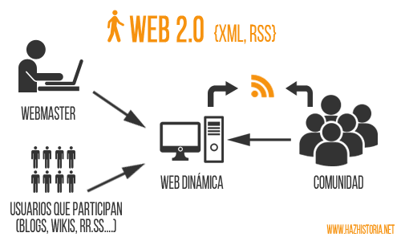

## **Web 2.0 features**

* Simplify website usability.
* Saves users time.
* Permits easier interactions.
* Facilitates publication, investigation and web content queries.
* Standardizes languages for better code reuse.

## **Web 2.0 weaknesses**

Everyone is author of some contents of the web. But, is inevitable that a website contains information from another website totally or partially. For avoid legal problems exists the Intellectual property Law, that consists in limit the access to another content that is not ours and for protect our content.

Be content author allows you to have full disposition and exclusive right for use this content without limitations included in this law. People are the total owner of his content.

The constant information exchange and weak security has caused data theft generating economic loses and virus propagation. Security is fundamental in technology.

Web 2.0 simplifies website usability and saves users time.

# **Web 3.0**

Web 3.0 is easier and more intuitive. In this version, appeared in 2006, the data can be found in any language, and is compatible with all types of software.

It tries to link user data with web data for transmit continuous information. The objective of this version is to create readable content for both users and machines.

Web 3.0 foments accessible content for applications that are not only the browser, for example, artificial intelligence or 3D web.

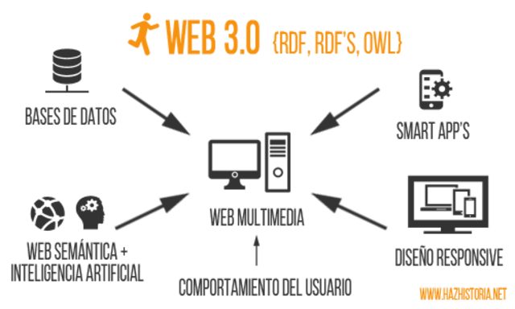

## **Functioning of web 3.0**

For the web can obtain a good data definition, it uses different technologies in distinct layers for help to web infrastructure becomes global. Some of these technologies are:

* XML: Provides an element syntax for structure documents information.
* RDF (Resource Definition Framework): Shows web information in a more simple and descriptive way.

## **Application fields of web 3.0**

* Social networks and blogs. This web version can aggregate different data for enrich information search possibilities and connect him with others.
* Documental search.
* Information search on Internet.
* Electronic commerce.
* Industry, investigation and development.